Observations 1:

Each changes is having the Multiple Change State even post selecting the current month in the filter.

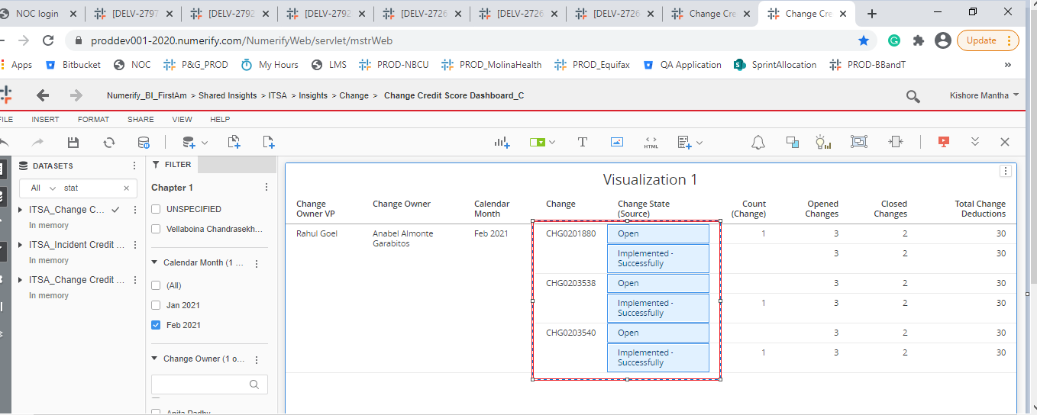

Observation 2:

The Change counts from the details grids are not matched with opened changes or closed change count in the snapshot cube.

